Brian Santana

Linux Administration

**Lab 3 Sed**

**1.**Change the name Meg to Megan

The s at the start stands for substitute by placing the name with a / infront it lets us replace meg with megan

Input: sed s/Meg/Megan/ datebook  
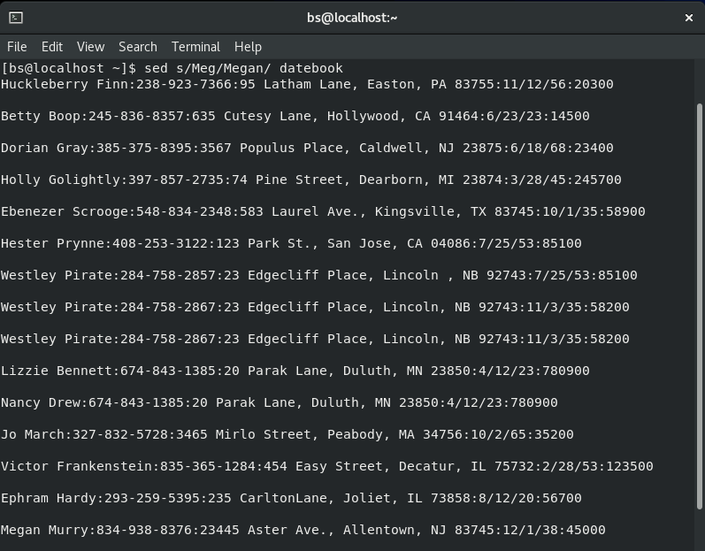  
**2.**Delete the last  3 lines.

d$ deletes lines and by putting the 50 in front it serves as a start point then deletes the 3 lines  
Input: sed ’50,$d’ datebook

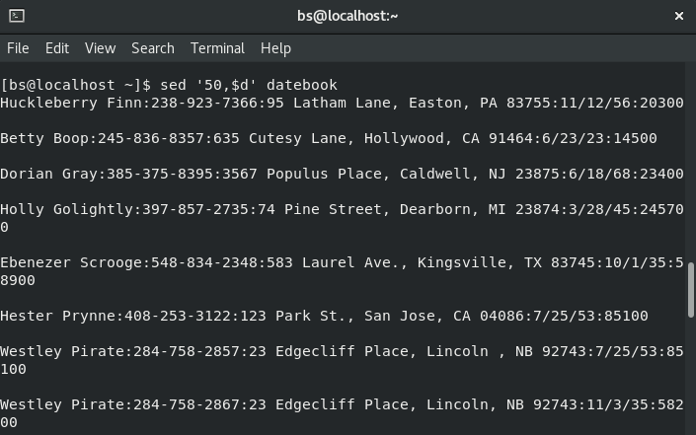  
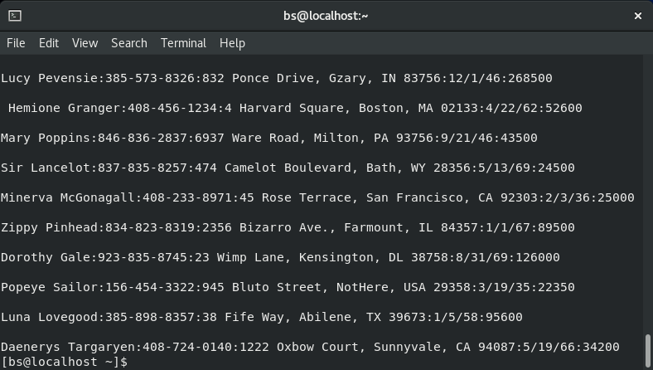

**3.**Print lines 2 through 4 .

The -n is there so only lines 2-4 print   
Input: sed -n ‘2,4p’ datebook



**4.**Delete lines containing Place.

Putting place inbetween the / makes it the targeted word putting d afterwards makes it delete any line with place  
Input: sed ‘/Place/d’ datebook

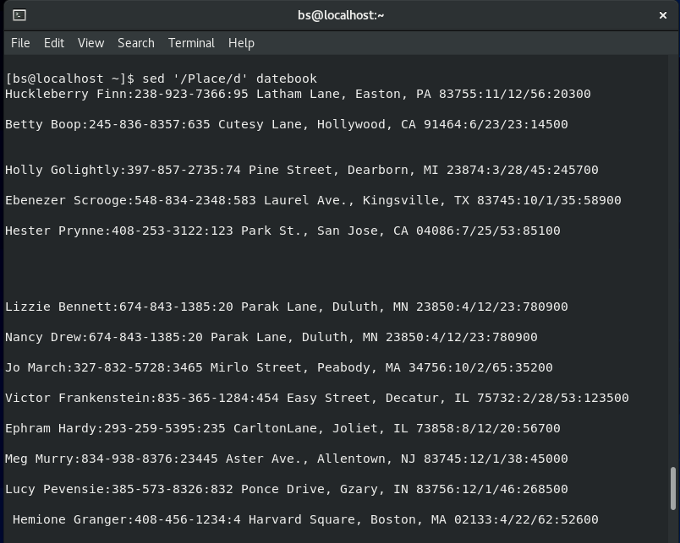  
**5.**Print all lines where the birthdays are in the first week of the month.  Be careful of the dates for birthdays, the format is MM/DD/YY

The reason for the 0-9 is so it prints any number in between that range as for the / being in brackets its to avoid having the program misread the slashes as something else and the 1-7 represents the first week.  
Input: sed -n ‘/[0-9][/][1-7][/][0-9]/p’ datebook

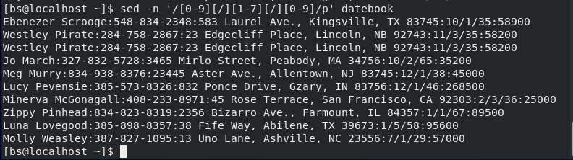  
**6.**Append three asterisks to the end of lines starting with Sir

a\ is the append command   
Input: sed ‘/Sir/a\***’ datebook

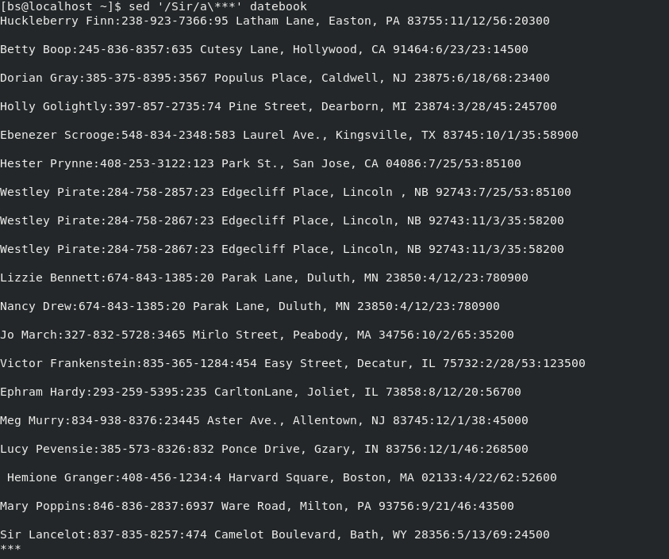  
**7.**Replace the line containing "Westley Pirate" with the phrase "As you wish."

Same explanation as 1  
Input: sed ‘s/Westley Pirate/As you wish/’ datebook

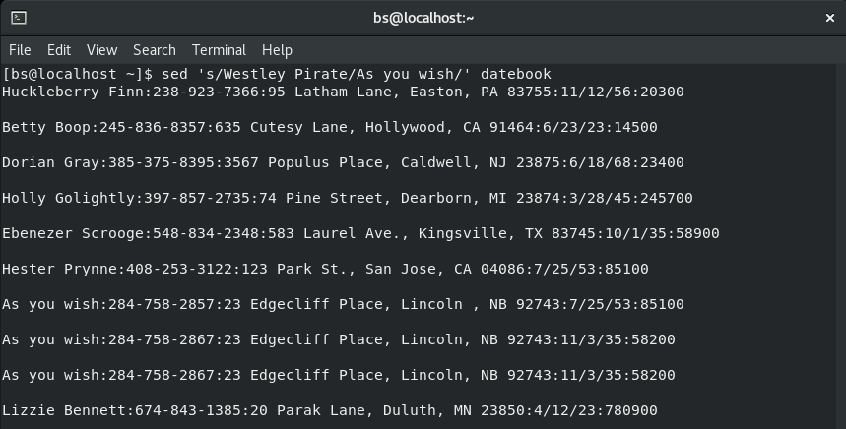  
**8.** Change Minerva McGonagall's birthday to 12/25/1960 . Assume you don't know Minerva's original birthday. Use a regular expression to search for it.

To replace the birthday without knowing the number you need to first specify the name by putting it in // then add an s for substitute the add [0-9] since you don’t know the birthday and it will search for it then the birthday you wish to switch it to which is 12/25/60   
Input: sed ‘/Minerva McGonagall/s,[0-9]\+/[0-9]\+/[0-9]\+,12/25/60,’ datebook

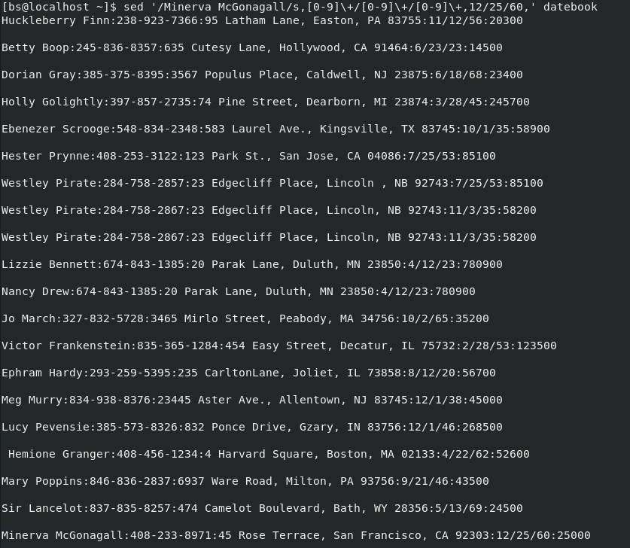  
**9.**Delete all blank lines.

Having the ^ at the start signifies the beginning of the anchor while the $ is the end and since there’s nothing in between it register that as blank and with the d it deletes all blank lines  
Input: sed ‘/^$/d’ datebook

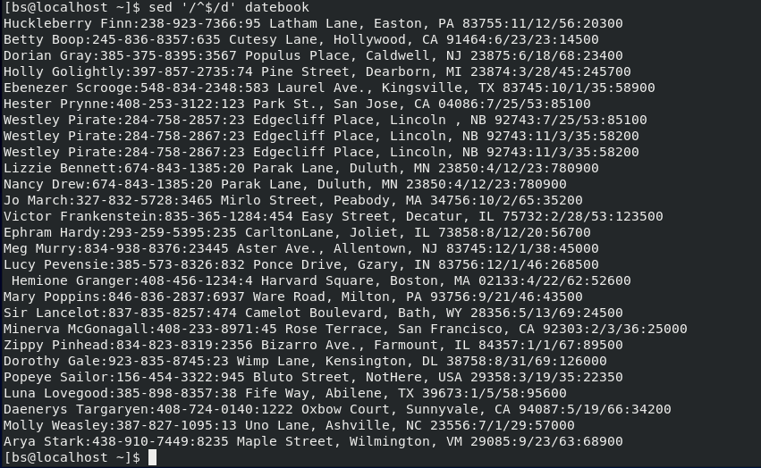  
**10.**Write a sed script that will  (actual sed script, NOT just the commands on the command line)

**a.**Insert above the first line the title  - Great Literary Characters -.

**b.**Remove the duplicate lines

**c.**Print the contents of the file with the first name then the phone number.

**d.**Append at the end of the file "Happily Ever after. The End"

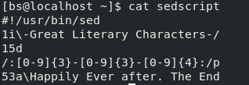

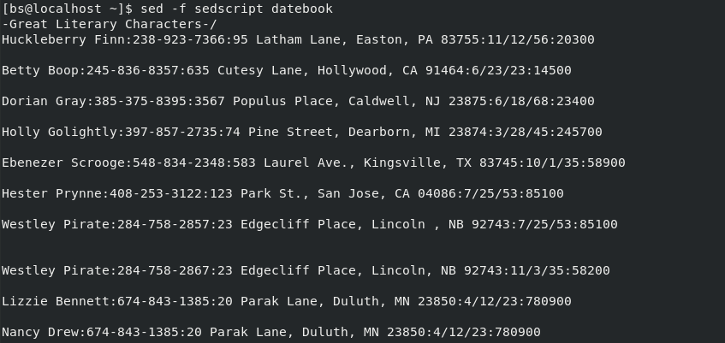



Sources:

<https://flylib.com/books/en/4.356.1/>

<https://www.geeksforgeeks.org/sed-command-in-linux-unix-with-examples/>